**Abstract**  
**Project Title: FreshFold – A Smart Laundry Management System**

FreshFold is a web-based laundry management system developed using HTML, PHP, JavaScript, and MySQL to digitize and streamline laundry services in college campuses. It addresses common issues such as manual errors and lack of tracking, ensuring real-time updates and seamless interaction between students and laundry staff. The system supports three user roles—Students, Laundry Staff, and Administrators. Students can submit laundry forms online, track bag status, receive notifications, make payments, cancel requests, and report missing or damaged items. Laundry staff can manage incoming bags, update status, and handle student issues, while administrators oversee all activities, manage users, and generate reports.

The system ensures secure user authentication and offers role-based access to improve efficiency and data control. Built with a user-friendly interface, FreshFold is responsive across devices, ensures fast performance, maintains data reliability through backups, and follows security best practices. Its modular and scalable design allows for easy maintenance and future feature expansion, ultimately offering a reliable and transparent laundry service experience for students and staff.

**Requirements**

**1. Functional Requirements**

**User Registration and Login:** Secure sign-up and login functionality for students, laundry staff, and administrators.

**Laundry Request Submission:** Students can fill and submit laundry request forms online.

**Bag Tracking:** Students can track the status of their laundry in real time.

**Notifications:** Automated alerts for pickup, processing, completion, or issues.

**Issue Reporting:** Students can report missing or damaged items and request cancellations.

**Bag Management:** Laundry staff can log incoming bags, update statuses, and resolve student concerns.

**Admin Control Panel:** Administrators can manage users, monitor activities, and generate reports.

**2. Non-Functional Requirements**

**Usability:** Interface must be clean, responsive, and intuitive for all user types.

**Performance:** The system should process user actions within 2 seconds on average.

**Scalability:** Should support expansion for new users, laundry centers, or campuses.

**Security:** Data encryption, secure authentication, and role-based access control.

**Availability:** System should maintain >99% uptime with regular data backups.

**Portability:** Accessible on desktops, tablets, and smartphones through web browsers.

**Maintainability:** Modular codebase to allow easy bug fixes and future enhancements.

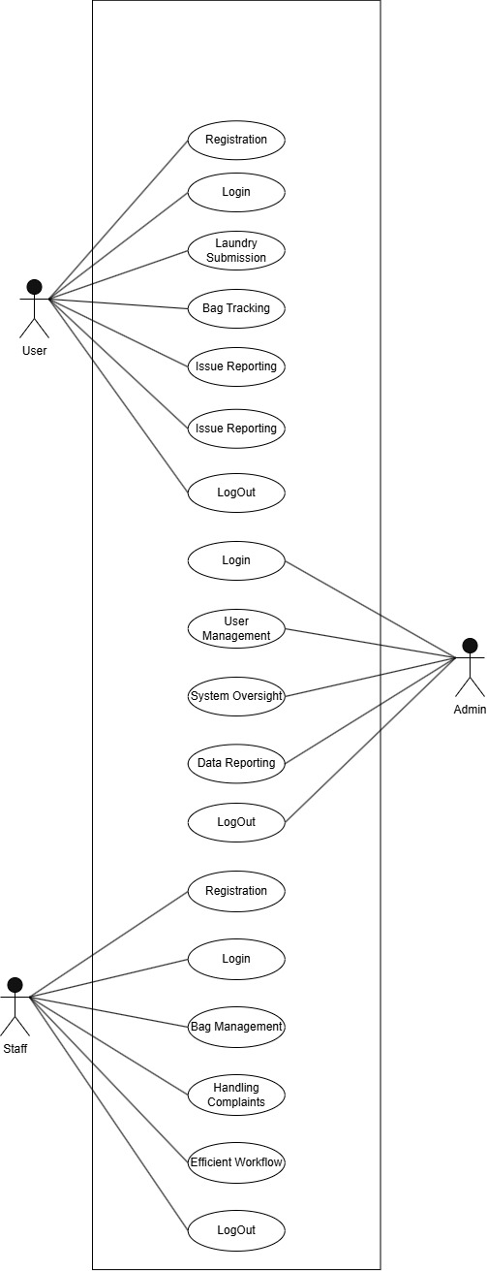

**Use Case Diagram**

# Use Case Descriptions – Fresh Fold Laundry Management System

## Use Case ID: UC-001

|  |  |
| --- | --- |
| Use Case Name | Student Login |
| Actor(s) | Student |
| Description | Allows students to securely log in to the laundry management system. |
| Preconditions | Student has valid credentials. |
| Postconditions | Student is authenticated and redirected to the dashboard. |
| Basic Flow | 1. Open login page 2. Enter credentials 3. Click 'Login' 4. Redirect to student dashboard |
| Alternative Flow(s) | 1. Invalid credentials → Show error 2. Session expired → Re-login required |
|  | |

## Use Case ID: UC-002

|  |  |
| --- | --- |
| Use Case Name | Student Logout |
| Actor(s) | Student |
| Description | Ends the student’s session securely. |
| Preconditions | Student is logged in. |
| Postconditions | Session is destroyed and redirected to login page. |
| Basic Flow | 1. Click 'Logout' 2. End session 3. Redirect to login page |
| Alternative Flow(s) | 1. Session timeout → Auto logout |
|  | |

## Use Case ID: UC-003

|  |  |
| --- | --- |
| Use Case Name | Submit Laundry Form |
| Actor(s) | Student |
| Description | Allows students to submit a laundry form with details. |
| Preconditions | Student is logged in. |
| Postconditions | Form is submitted and saved in system. |
| Basic Flow | 1. Login 2. Open laundry form 3. Fill details 4. Submit form 5. Receive confirmation |
| Alternative Flow(s) | 1. Incomplete form → Show error 2. Duplicate submission → Show warning |
|  | |

## Use Case ID: UC-004

|  |  |
| --- | --- |
| Use Case Name | Track Bag Status |
| Actor(s) | Student |
| Description | Allows students to check real-time bag status. |
| Preconditions | Student is logged in and has submitted laundry. |
| Postconditions | Bag status is displayed to the student. |
| Basic Flow | 1. Login 2. Go to 'Track Status' 3. View current status |
| Alternative Flow(s) | 1. No data found → Show “No records” 2. Server issue → Show retry message |
|  | |

## Use Case ID: UC-005

|  |  |
| --- | --- |
| Use Case Name | Report Damaged/Missing Item |
| Actor(s) | Student |
| Description | Students report missing or damaged items. |
| Preconditions | Student is logged in. |
| Postconditions | Complaint is recorded and forwarded to staff. |
| Basic Flow | 1. Login 2. Open 'Report Issue' 3. Describe issue 4. Submit |
| Alternative Flow(s) | 1. Empty form → Show validation error |
|  | |

## Use Case ID: UC-006

|  |  |
| --- | --- |
| Use Case Name | Laundry Staff Login |
| Actor(s) | Laundry Staff |
| Description | Allows staff to log in securely. |
| Preconditions | Valid staff credentials. |
| Postconditions | Staff is authenticated and redirected to dashboard. |
| Basic Flow | 1. Open login page 2. Enter credentials 3. Click login |
| Alternative Flow(s) | 1. Invalid credentials → Show error |
|  | |

## Use Case ID: UC-007

|  |  |
| --- | --- |
| Use Case Name | Update Bag Status |
| Actor(s) | Laundry Staff |
| Description | Update and track laundry bag stages. |
| Preconditions | Staff is logged in. |
| Postconditions | Bag status is updated in the system. |
| Basic Flow | 1. Login 2. View assigned bags 3. Change status 4. Save update |
| Alternative Flow(s) | 1. Bag not found → Notify admin 2. System error → Show retry option |
|  | |

## Use Case ID: UC-008

|  |  |
| --- | --- |
| Use Case Name | Respond to Complaints |
| Actor(s) | Laundry Staff |
| Description | View and act upon student complaints. |
| Preconditions | Staff is logged in and has access. |
| Postconditions | Complaint status is marked handled. |
| Basic Flow | 1. Login 2. View complaints 3. Respond or resolve 4. Mark as closed |
| Alternative Flow(s) | 1. Complaint not valid → Reject 2. Issue escalated → Notify admin |
|  | |

## Use Case ID: UC-009

|  |  |
| --- | --- |
| Use Case Name | Admin Login/Logout |
| Actor(s) | Administrator |
| Description | Allows admin to login and logout securely. |
| Preconditions | Valid admin credentials. |
| Postconditions | Access granted or session terminated. |
| Basic Flow | 1. Open login 2. Enter credentials 3. Access admin panel 4. Click logout |
| Alternative Flow(s) | 1. Wrong credentials → Show error 2. Timeout → Auto logout |
|  | |

## Use Case ID: UC-010

|  |  |
| --- | --- |
| Use Case Name | Manage Users |
| Actor(s) | Administrator |
| Description | Admin adds/edits/removes student or staff accounts. |
| Preconditions | Admin is logged in. |
| Postconditions | User table is updated. |
| Basic Flow | 1. Login 2. Go to User panel 3. Choose add/edit/delete 4. Save |
| Alternative Flow(s) | 1. Invalid input → Show error 2. Duplicate user → Show warning |
|  | |

# FreshFold Laundry Management System – Use Cases

## Student Use Cases

|  |  |  |
| --- | --- | --- |
| Use Case ID | Use Case Name | Description |
| UC-01 | Register/Login | Student registers and logs in securely. |
| UC-02 | Logout | Student logs out securely. |
| UC-03 | Online Laundry Submission | Student submits laundry forms online without visiting the laundry room. |
| UC-04 | Bag Tracking | Student tracks the real-time status of their laundry bag. |
| UC-05 | Receive Notifications | Student receives updates or alerts about laundry status. |
| UC-06 | Report Issues | Student reports missing or damaged clothing items. |

## Laundry Staff Use Cases

|  |  |  |
| --- | --- | --- |
| Use Case ID | Use Case Name | Description |
| UC-07 | Register/Login | Laundry staff logs into the system securely. |
| UC-08 | Logout | Laundry staff logs out securely. |
| UC-09 | Bag Management | Laundry staff manages incoming laundry and updates status. |
| UC-10 | Handle Complaints | Laundry staff responds to student-reported issues. |
| UC-11 | Efficient Workflow | Staff improves task handling through digital tracking. |
|  |  |  |

## Administrator Use Cases

|  |  |  |
| --- | --- | --- |
| Use Case ID | Use Case Name | Description |
| UC-12 | Login to Admin Dashboard | Administrator logs into a secure dashboard. |
| UC-13 | Logout | Administrator logs out securely. |
| UC-14 | User Management | Admin adds, removes, or modifies student and staff accounts. |
| UC-15 | System Oversight | Admin monitors all activities and ensures smooth operation. |
| UC-16 | Data Reporting | Admin generates reports on user activities and service usage. |